Week 5 — Complete Notes
ARP · RARP · DHCP · IPv4 · IPv6 · Mobile IP
Full coverage of all topics, diagrams and worked examples

1. Network Layer — Overview
The network layer is the part of the internet that carries data from one computer to another anywhere in the world. It uses several helper protocols to do this job correctly.
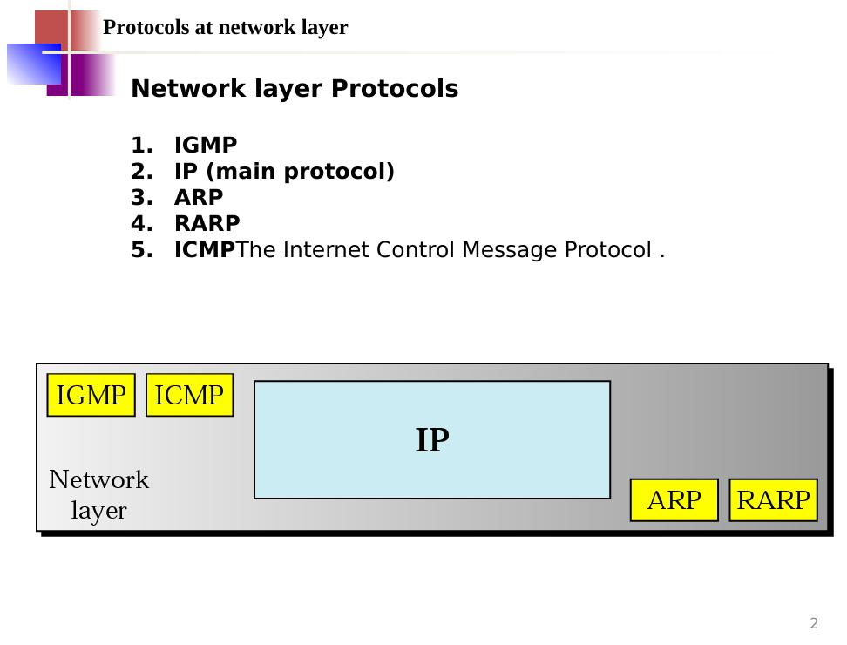
Figure 1.1 — The five protocols living in the network layer: IGMP, IP, ARP, RARP, ICMP.

1.1 Network Layer Protocols
- IGMP — helps send one message to many computers at once (multicasting).
- IP (Internet Protocol) — the main protocol; carries data from source to destination.
- ARP (Address Resolution Protocol) — finds a computer's physical (MAC) address from its IP address.
- RARP (Reverse ARP) — the opposite of ARP; finds an IP address from a physical address.
- ICMP (Internet Control Message Protocol) — reports errors and status messages.

1.2 IP Criteria
- IP is responsible for host-to-host delivery of datagrams from a source to a destination.
- IP needs ARP to find the MAC (physical) address of the next hop.
- IP is designed for unicast delivery (one sender → one receiver).
- For multicasting (one sender → many receivers), IP uses IGMP.
- When something goes wrong during delivery, IP uses ICMP to report the error.
- The current latest version is IPv6.

2. ARP — Address Resolution Protocol

2.1 The Two-Address Problem
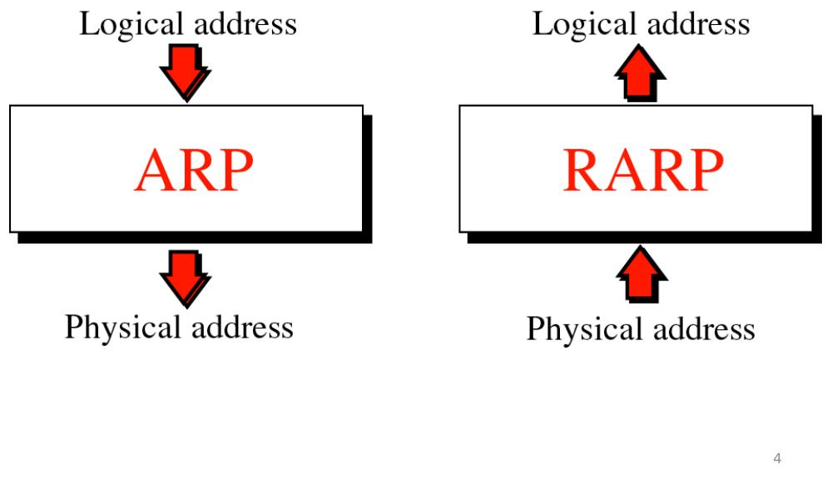
Figure 2.1 — ARP converts a logical (IP) address → physical (MAC) address. RARP does the opposite.
Every computer has two types of address:
- IP address (logical address): works everywhere in the world, like a universal house number.
- MAC address (physical address): works only inside one local network, like a fingerprint of the network card.
To send data on a local network (like Ethernet), a computer must know the MAC address of the next hop. ARP is the helper that finds this MAC address when only the IP address is known.
Why do we need both? Because:
- A physical network (like Ethernet) can carry more than one type of network-layer protocol (e.g., IP, IPX) at the same time.
- An IP packet may travel across different kinds of physical networks (e.g., Ethernet → Token Ring) on its journey.
- So delivery of a packet needs two levels of addressing. Both IP and MAC are equally necessary.

2.2 Mapping: Static vs. Dynamic

Static Mapping
A fixed table is kept on every machine, listing which IP address belongs to which MAC address. Problem: this table must be updated manually whenever a machine changes its MAC address (e.g., new network card, changed network, turned off/on).

Dynamic Mapping — ARP and RARP
Instead of a fixed table, the computer asks the question live, right when it needs the answer:
- ARP: "I know the IP address — tell me the MAC address."
- RARP / DHCP: "I know the MAC address — tell me the IP address."

2.3 ARP Operation
When a computer needs a MAC address, it shouts (broadcasts) an ARP Request across the whole local network: "Who has IP address X?" Every computer hears it. Only the one with that IP address replies quietly (unicast) with its MAC address.
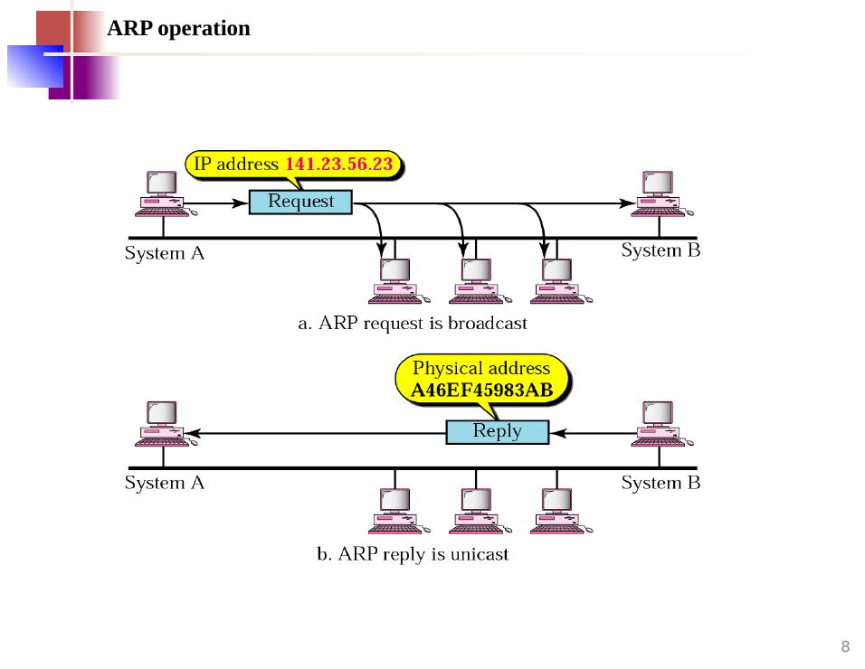
Figure 2.2 — (a) ARP Request is broadcast to everyone; (b) ARP Reply is unicast back to the sender only.
📌 Note: ARP request → Broadcast (shout to all). ARP reply → Unicast (reply to one).

2.4 Proxy ARP
A Proxy ARP router can answer ARP requests on behalf of computers that are on a different (added) subnetwork. This is useful when a new group of computers is attached to the network — the proxy router pretends to be all of them.
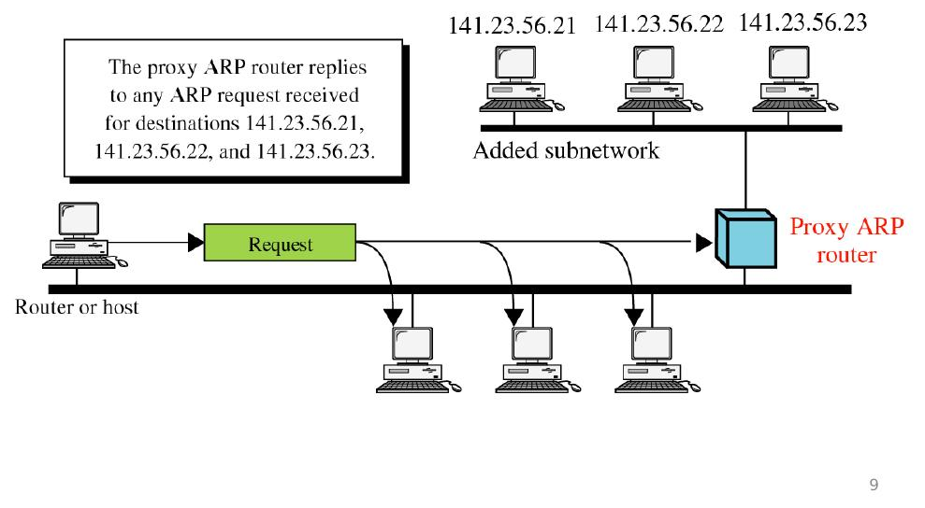
Figure 2.3 — Proxy ARP router answers requests for machines on the added subnetwork.

2.5 ARP Packet Format
An ARP message is written on a small form with these fixed boxes:
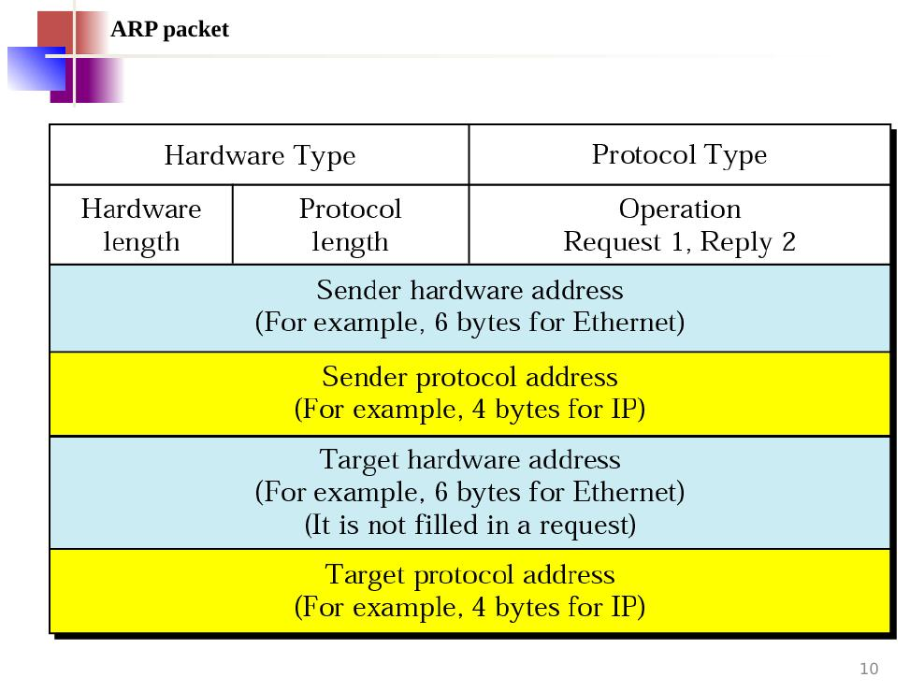
Figure 2.4 — Fields inside an ARP packet. Operation = 1 (Request) or 2 (Reply).
- Hardware Type: type of physical network (e.g., 1 = Ethernet).
- Protocol Type: type of logical protocol (e.g., 0x0800 = IP).
- Hardware / Protocol Length: size of the addresses in bytes.
- Operation: 1 = Request, 2 = Reply.
- Sender hardware address: MAC address of the sender.
- Sender protocol address: IP address of the sender.
- Target hardware address: MAC address of the target (unknown in a request — left as 000…000).
- Target protocol address: IP address of the target.

2.6 ARP Encapsulation
An Ethernet frame has the following structure. The Type field (EtherType) identifies what is carried in the payload — for ARP this is 0x0806, for RARP it is 0x8035.
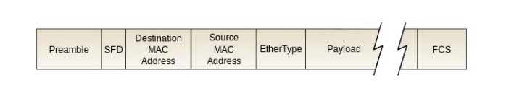
Figure 2.5a — Ethernet frame structure: Preamble, SFD, Destination MAC, Source MAC, EtherType (2 bytes), Payload, and FCS.
Before travelling on the wire, an ARP packet is placed inside an Ethernet frame as the payload. The Ethernet Type field is set to 0x0806 to say "this carries ARP".
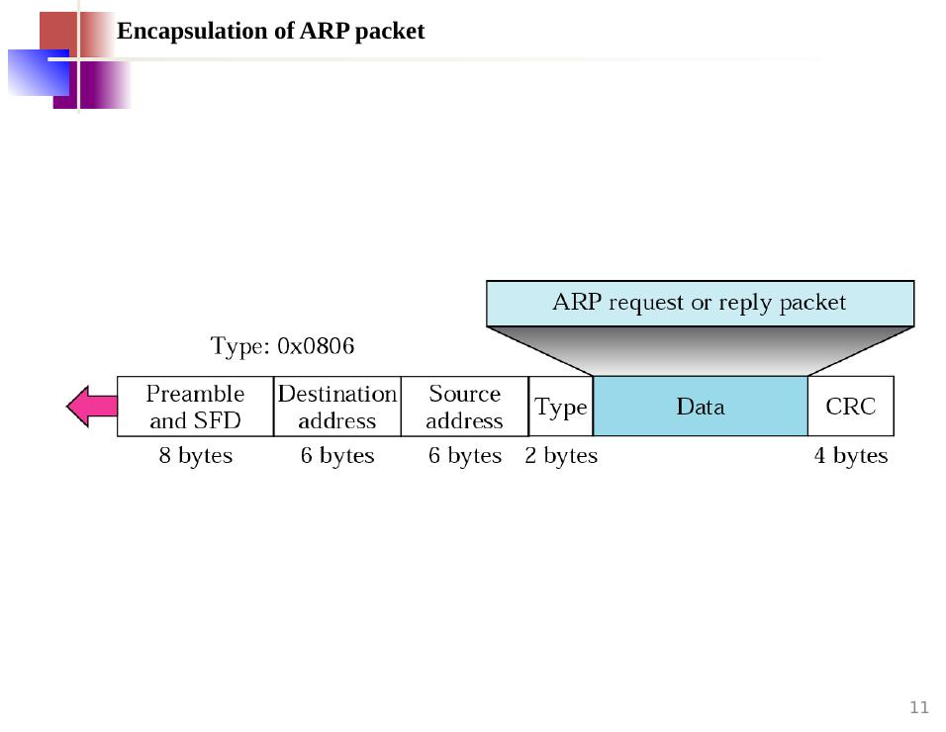
Figure 2.5 — ARP packet wrapped inside an Ethernet frame. Type 0x0806 means ARP.

2.7 Four Cases Where ARP is Used
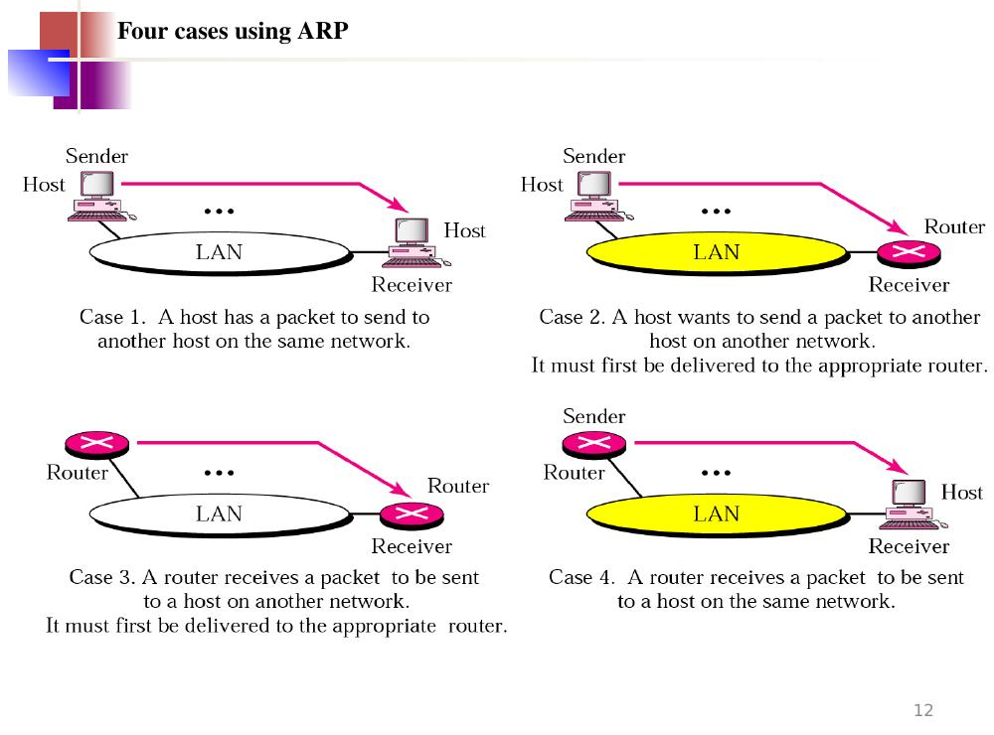
Figure 2.6 — The four cases: (1) host→host same network; (2) host→router for other network; (3) router→router for other network; (4) router→host same network.
- Case 1: Sender is a host, target is a host on the same network. ARP finds the target MAC directly.
- Case 2: Sender is a host, target is on another network. ARP finds the MAC of the outgoing router.
- Case 3: Sender is a router, next hop is another router on the same network. ARP finds that router's MAC.
- Case 4: Sender is a router, target is a host on the same network. ARP finds the host's MAC.

2.8 Worked Example — ARP Request and Reply
Host A (IP: 130.23.3.20, MAC: B23455102210) wants to send data to Host B (IP: 130.23.43.25, MAC: A46EF45983AB). Both are on the same Ethernet network.
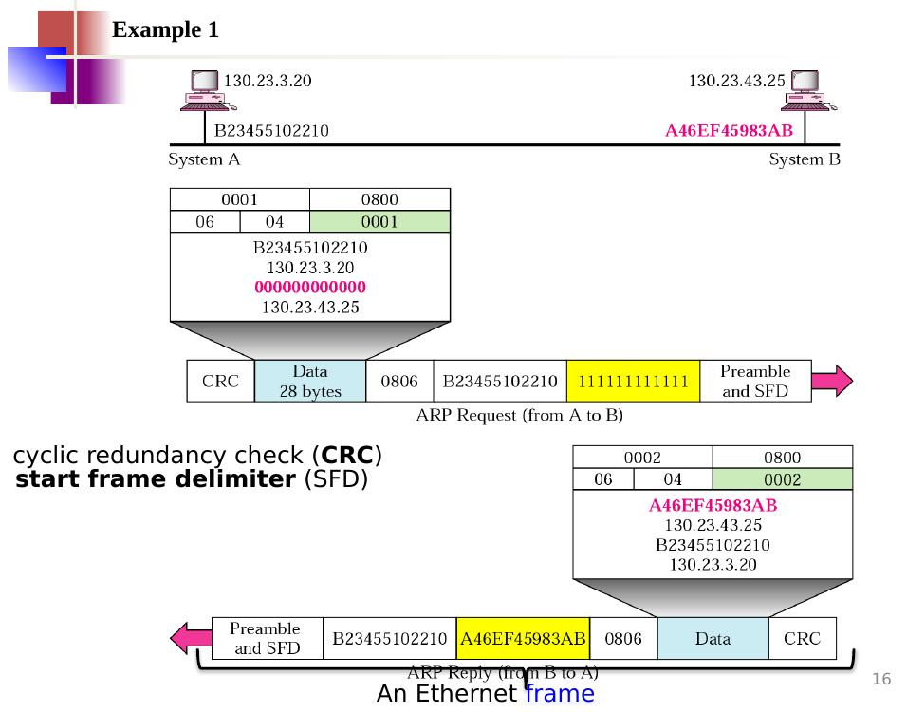
Figure 2.7 — ARP Request (top) sent by A with target MAC = 000000000000 (unknown). ARP Reply (bottom) sent by B with its real MAC A46EF45983AB. Each is wrapped in an Ethernet frame with Type 0x0806 (ARP). CRC = cyclic redundancy check; SFD = start frame delimiter.
📌 Note: In the ARP request frame, the destination MAC in the Ethernet header is set to all 1s (broadcast: 111111111111). In the reply, it is set to the exact MAC of the requester.

3. RARP — Reverse Address Resolution Protocol
RARP is the mirror image of ARP. A computer knows its own MAC address but does not know its IP address (for example, a diskless workstation that just started up). It broadcasts a RARP Request and a RARP server on the network replies with the IP address.

3.1 RARP Operation
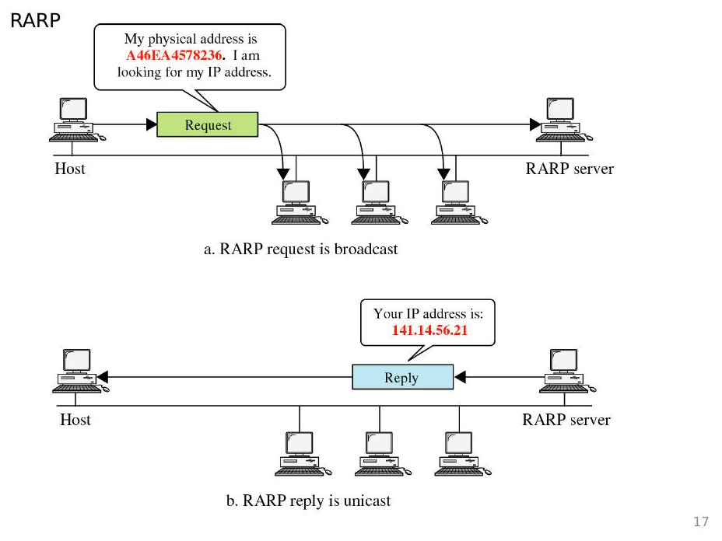
Figure 3.1 — (a) RARP Request broadcast: "My MAC is A46EA4578236 — what is my IP address?" (b) RARP Reply unicast: "Your IP address is 141.14.56.21"

3.2 RARP Packet Format
The RARP packet has the same fields as the ARP packet, but the operation codes are 3 (Request) and 4 (Reply), and the sender protocol address field is left empty in the request because that is exactly what we are asking for.
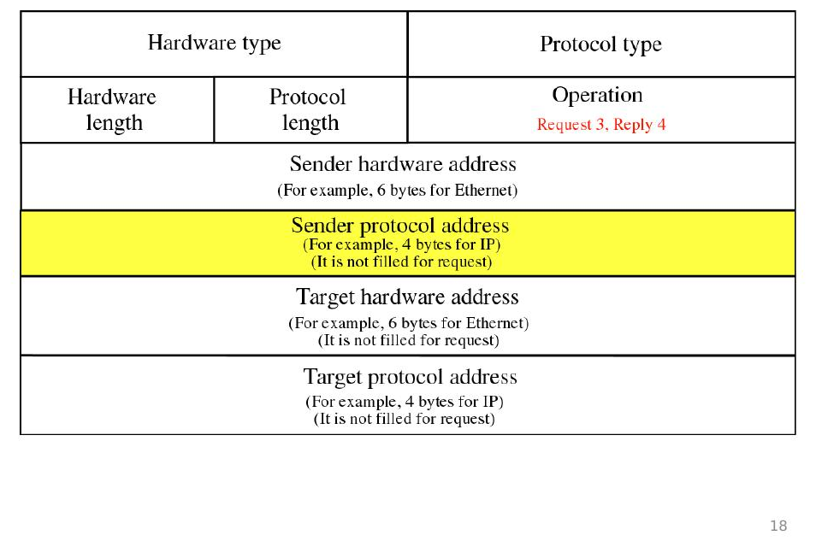
Figure 3.2 — RARP packet fields. Operation = 3 (Request) or 4 (Reply). Yellow = not filled in a request.

3.3 RARP Encapsulation
Just like ARP, the RARP packet is carried inside an Ethernet frame. The Ethernet Type field is set to 0x8035 to say "this carries RARP".
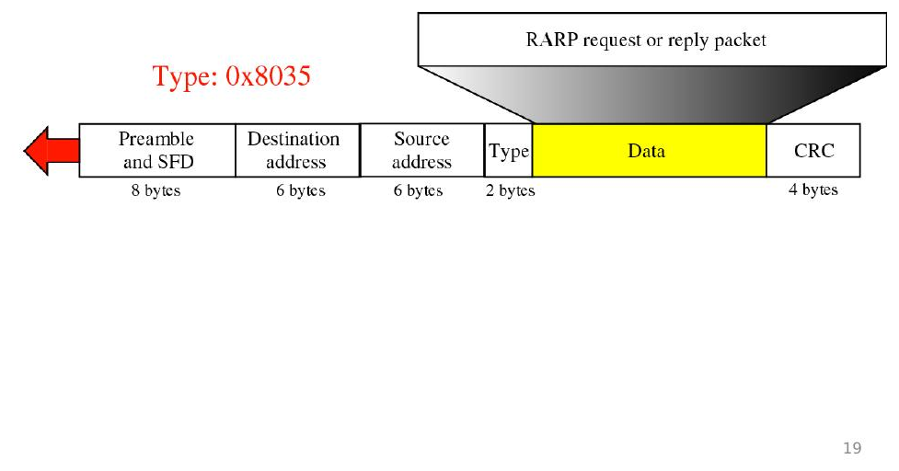
Figure 3.3 — RARP packet wrapped in an Ethernet frame. Type 0x8035 = RARP.

3.4 Limitations of RARP
- RARP only gives an IP address — it does not give other settings like subnet mask, gateway, or DNS server.
- RARP requires a special RARP server on every network segment, which is expensive to maintain.
- Because of these limitations, RARP has been replaced by the more powerful DHCP.

4. DHCP — Dynamic Host Configuration Protocol
DHCP is the modern replacement for RARP. It gives a computer its IP address automatically plus many other settings — all at once, when the computer first starts up.

4.1 How DHCP Works
- DHCP is a client–server program. The client (new computer) asks; the server (DHCP server) answers.
- The DHCP server has two address lists: a static (fixed) list for machines that must always get the same IP, and a dynamic (temporary) pool for everyone else.
- If a machine's MAC address is in the fixed list, it always gets its fixed IP address.
- Otherwise, the server lends an IP address from the pool for a limited time, called a lease.

4.2 DHCP Message Exchange
The client and server talk using UDP messages. The server listens on port 67; the client uses port 68.
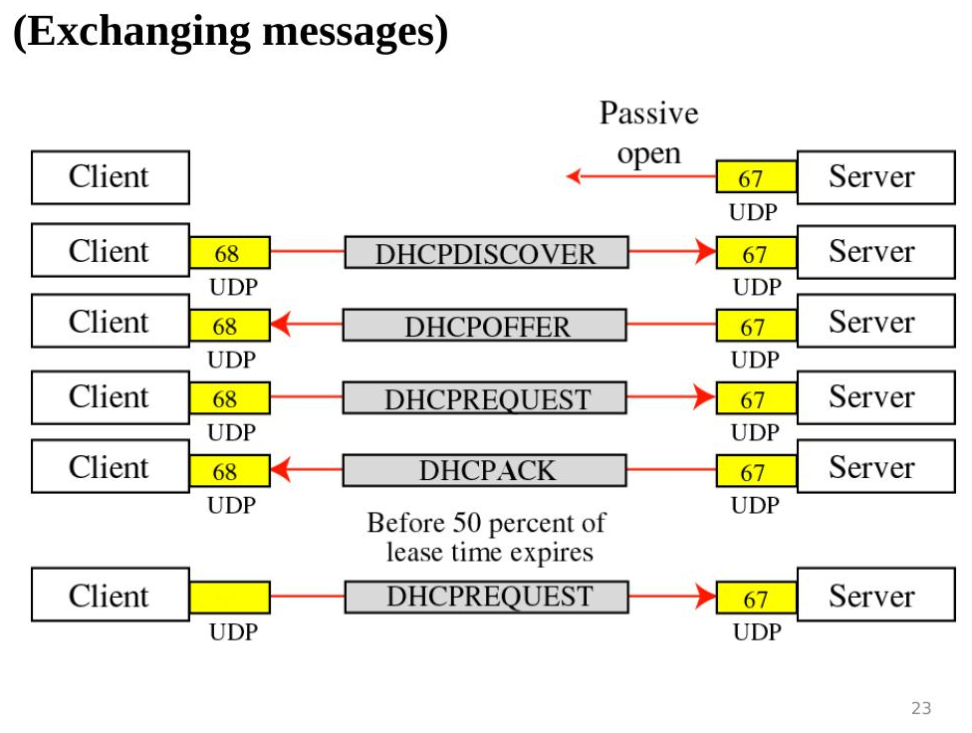
Figure 4.1 — Normal DHCP flow: DISCOVER → OFFER → REQUEST → ACK. Before the lease hits 50%, the client sends a new REQUEST to renew.
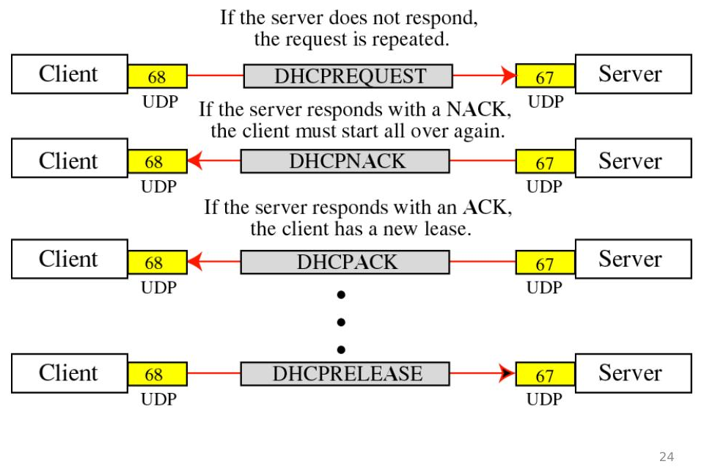
Figure 4.2 — Renewal outcomes: NACK (start over) or ACK (new lease). At the end, the client sends DHCPRELEASE to give back the address.

4.3 DHCP Transition States
A DHCP client goes through the following stages to get and keep its IP address:
- Initializing — the client broadcasts DHCPDISCOVER to find any DHCP server. If no OFFER received, it tries 4 times every 2 seconds, then waits 5 minutes before trying again.
- Selecting — servers reply with DHCPOFFER (including IP address and lease duration). The server that sends OFFER locks that IP so no other client can use it. The client picks one server and sends DHCPREQUEST.
- Requesting — the client waits for DHCPACK from the server. The ACK binds the client's physical address to its new IP address.
- Bound — the client uses its IP address. If the lease expires, it returns to Initializing. If 50% of the lease passes, the client sends a new DHCPREQUEST for renewal. If the server agrees, it sends DHCPACK.
- Renewing — the client received DHCPACK and renews the lease. If lease time reaches 87.5% and no ACK has been received, the client sends DHCPREQUEST and moves to Rebinding.
- Rebinding — if the server sends DHCPACK, the lease is renewed. If the lease expires or DHCPNACK is received, the client goes back to Initializing.
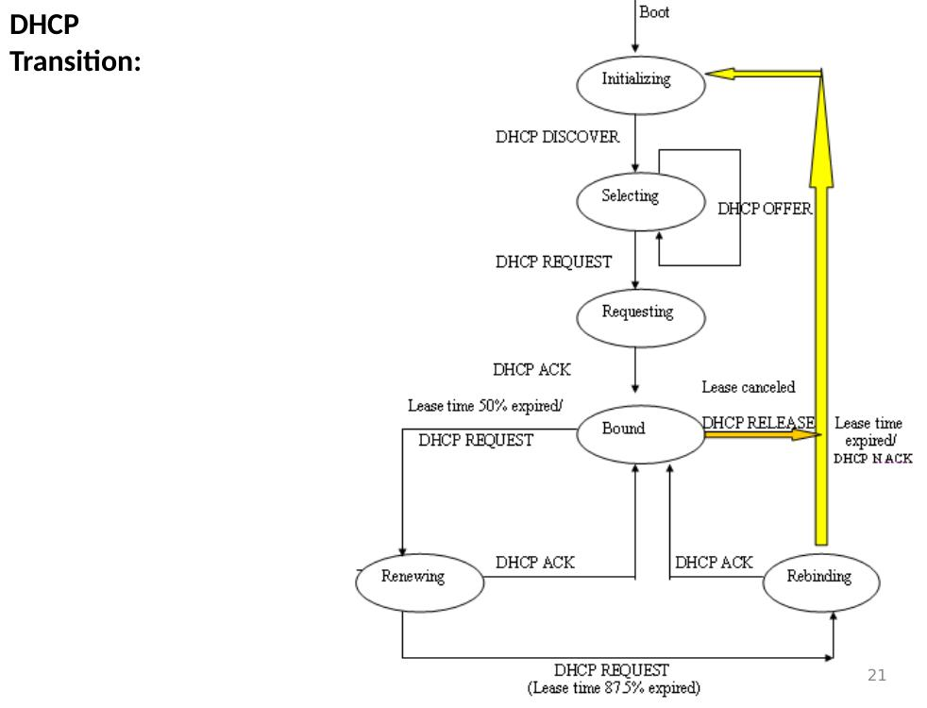
Figure 4.3 — Full DHCP state transition diagram.

5. IP — The Datagram (IPv4)

5.1 Nature of IP
- IP is an unreliable and connectionless protocol — it does its best but does not guarantee delivery.
- IP does not set up a fixed path (no connection setup before sending).
- If a packet arrives with a damaged header, IP simply discards it. Error checking of the data itself is left to higher-level protocols (like TCP).
- For reliable delivery, IP is used together with TCP.
Since IP is connectionless, each datagram travels independently. If a queue at a router is full, the datagram may be rerouted through a different path, so datagrams may arrive at the destination out of order.
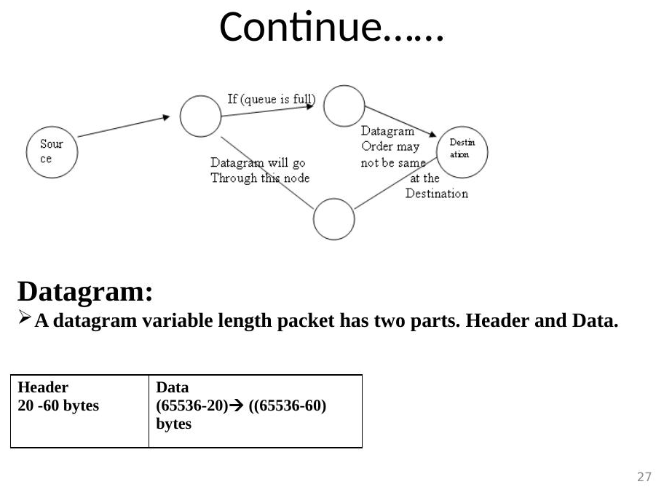
Figure 5.1 — Connectionless routing: if the queue is full, a datagram takes an alternate path. Order at destination may differ from sending order.
📌 Note: Total Length field defines the total length of the datagram including the header.

5.2 IP Datagram Structure
An IP datagram (packet) has two parts: a header (20 to 60 bytes) which contains all the control information, and the data area which carries the actual content. Data size = Total Length − Header Length. Max total = 65,535 bytes.
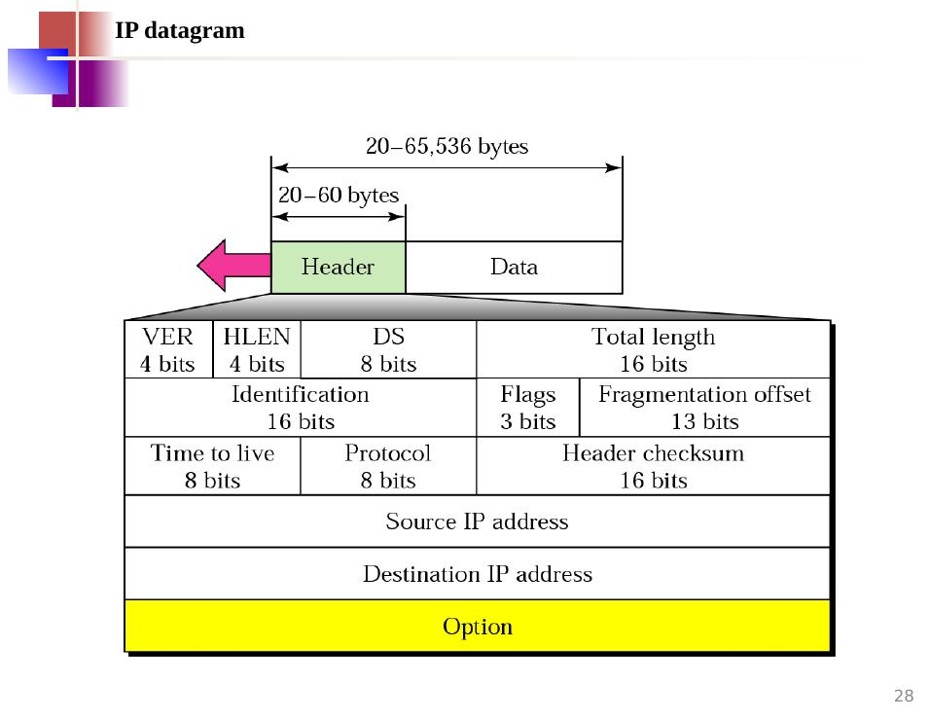
Figure 5.2 — IP datagram structure: variable-length header (20–60 bytes) followed by data.
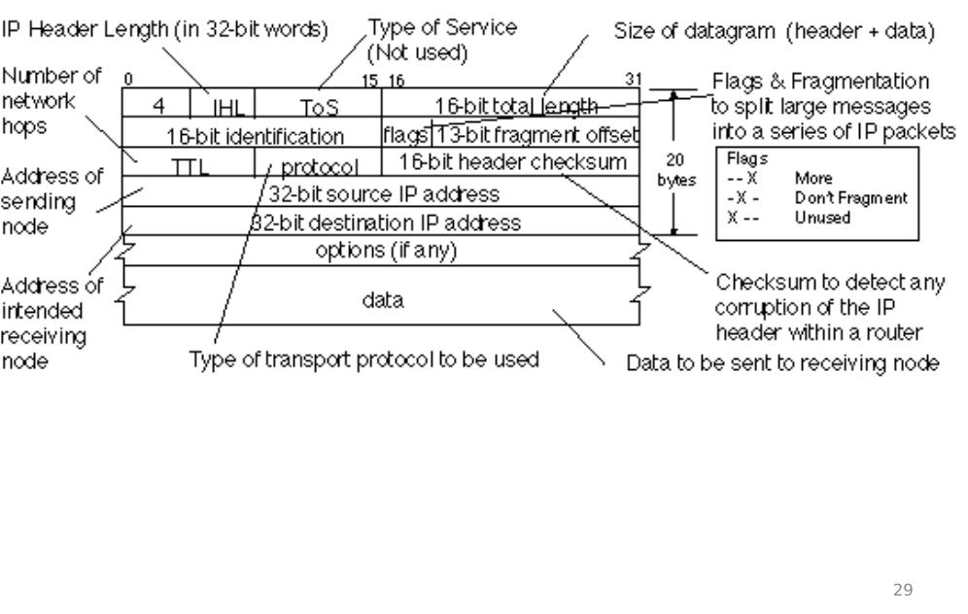
Figure 5.3 — Annotated IP header showing all fields and their purposes at a glance.

5.3 IP Header Fields — One by One
- VER (4 bits): IP version number (4 for IPv4).
- HLEN (4 bits): header length measured in 4-byte words. Minimum 5 (=20 bytes).
- Differentiated Services / DS (8 bits): used for quality-of-service — some packets can be given priority treatment.
- Total Length (16 bits): size of the whole datagram (header + data), up to 65,535 bytes.
- Identification (16 bits): a unique number for each datagram. All fragments of the same datagram share this number.
- Flags (3 bits): controls fragmentation (see below).
- Fragmentation Offset (13 bits): tells which part of the original datagram this fragment represents.
- TTL — Time to Live (8 bits): a countdown. Each router reduces it by 1. When it reaches 0, the packet is discarded (prevents forever-looping packets).
- Protocol (8 bits): tells which upper-layer protocol should receive the data (see table below).
- Header Checksum (16 bits): error-check number for the header only. Recalculated at every router.
- Source IP Address (32 bits): IP address of the sender.
- Destination IP Address (32 bits): IP address of the receiver.
- Options: optional extra fields, like recording the route, timestamps, etc.

5.4 Protocol Field Values
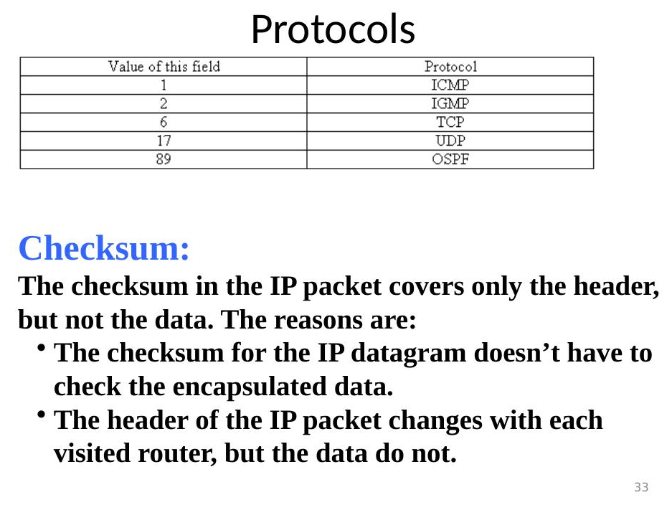
Figure 5.3 — Protocol field values: 1=ICMP, 2=IGMP, 6=TCP, 17=UDP, 89=OSPF.

5.5 Multiplexing and Demultiplexing
At the sender, many upper-layer protocols (TCP, UDP, ICMP, IGMP, OSPF) all feed their data into the one IP protocol — this combining is called multiplexing. At the receiver, IP looks at the Protocol field and delivers the data to the correct upper-layer protocol — this is demultiplexing.
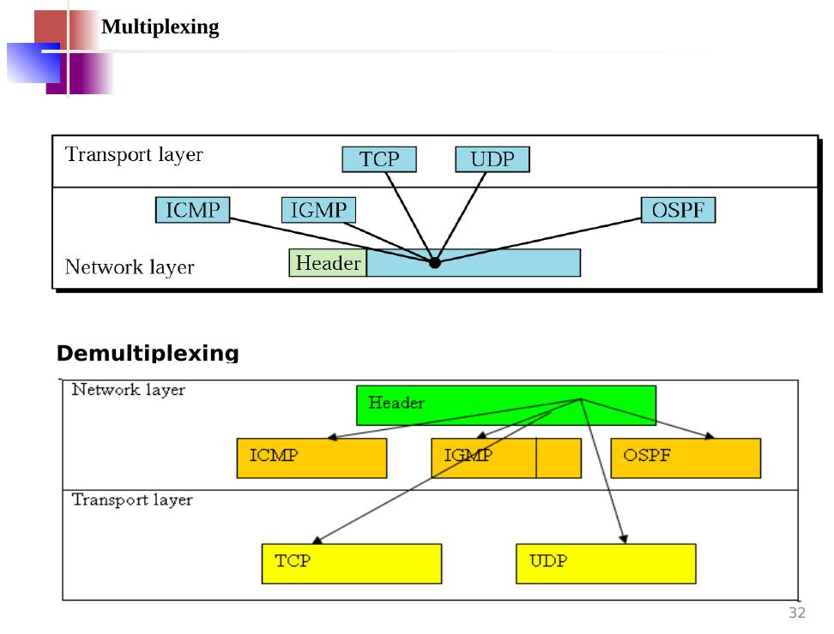
Figure 5.4 — Multiplexing (top): multiple upper protocols merge into IP. Demultiplexing (bottom): IP splits data back out to the right protocol.

5.6 The Checksum
The checksum in the IP header covers only the header, not the data. Why?
- The data is already protected by its own higher-level checksum (e.g., TCP or UDP checksum).
- The header changes at every router (e.g., TTL decreases by 1 each hop), so the checksum must be recalculated at every router. The data does not change, so it does not need to be rechecked each hop.
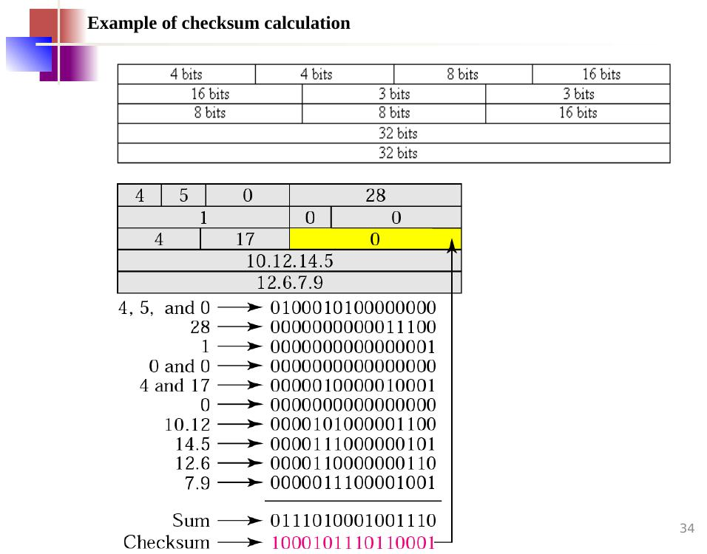
Figure 5.5 — Worked example of header checksum calculation: each header row is converted to binary and summed; the complement of the sum is the checksum.

6. Fragmentation

6.1 What is MTU?
Each physical network has a maximum size of data it can carry in one frame. This limit is called the MTU (Maximum Transfer Unit). The maximum length of an IP datagram equals the largest MTU = 65,535 bytes. For other physical networks, the datagram must be divided to pass through. A datagram can be fragmented by the source host or any router in the path. Reassembly is always done at the final destination.
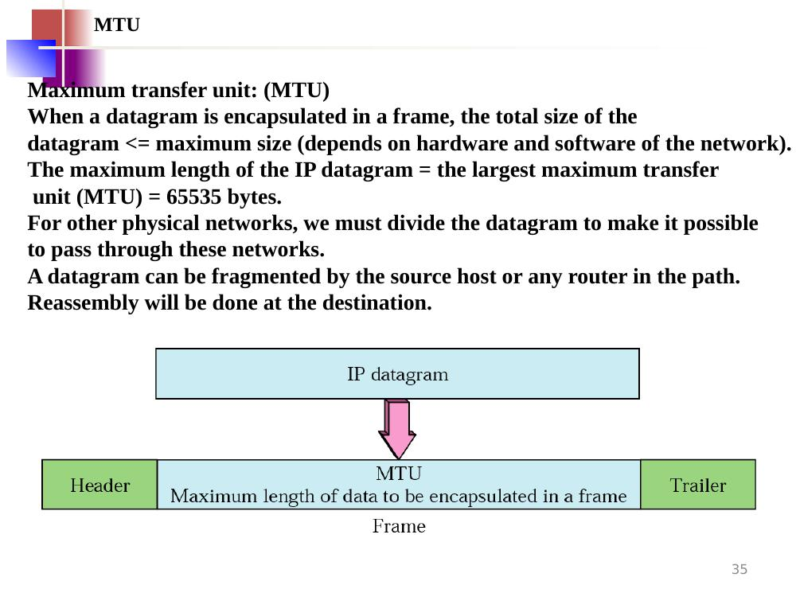
Figure 6.1 — An IP datagram is encapsulated in a frame. The MTU limits the maximum data size that fits in one frame.

6.2 Flags Field — 3 bits
- Bit 1 (Reserved): always 0, unused.
- Bit 2 — "Do Not Fragment" (D): value 0 = fragmentation allowed; value 1 = must NOT fragment. If the datagram can't cross a network without being fragmented and this bit is 1, it is simply discarded.
- Bit 3 — "More Fragments" (M): value 1 = more pieces follow this one; value 0 = this is the last (or only) piece.

6.3 Fragmentation Offset
This 13-bit field shows where in the original datagram this fragment belongs. The offset is measured in units of 8 bytes (so the actual byte position = offset × 8).
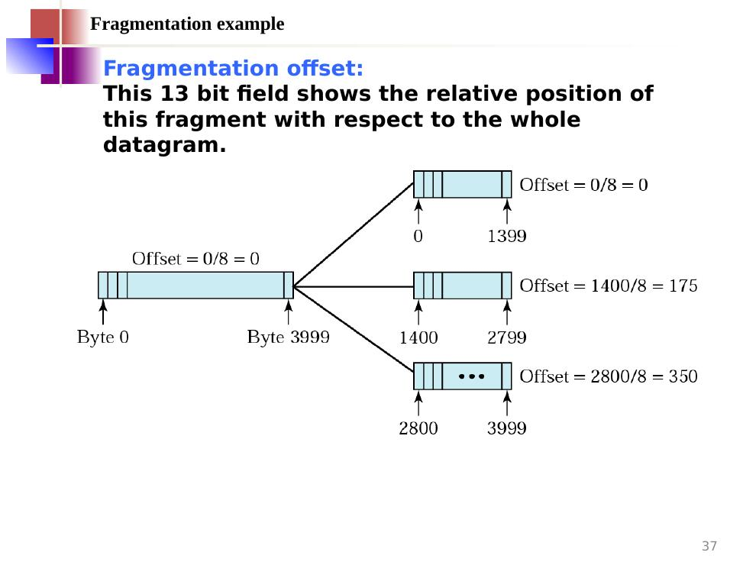
Figure 6.1 — A 4000-byte datagram split into 3 fragments of 1400 bytes each. Offsets: 0/8=0, 1400/8=175, 2800/8=350.
📌 Note: All fragments from the same datagram share the same Identification number so the destination can put them back together.

7. IPv6

7.1 Comparison — IPv4 vs. IPv6 Network Layer
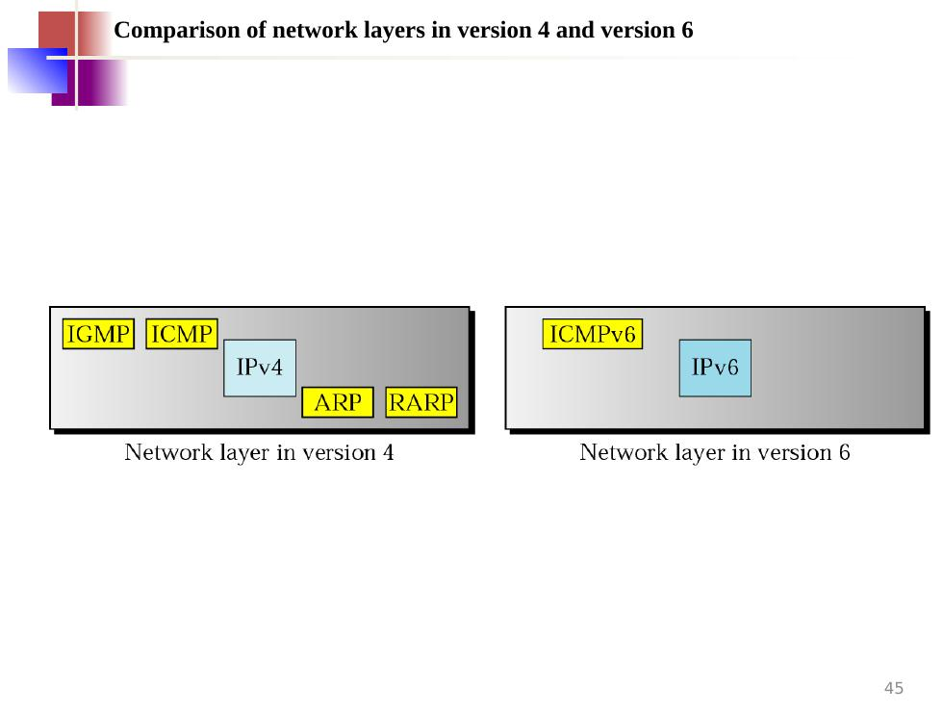
Figure 7.1 — IPv4 network layer (left) includes IGMP, ICMP, ARP, RARP alongside IP. IPv6 network layer (right) only needs ICMPv6 — ARP and RARP are no longer needed.

7.2 Demerits of IPv4 (Why IPv6 was Needed)
- Insufficient address space: IPv4 has a two-level address structure (net ID + host ID) categorised into five classes. The address space is insufficient for today's internet.
- No built-in security: IPv4 originally provided no encryption or authentication mechanism for data.
- No support for real-time traffic: Audio and video transmission requires minimum delay and resource reservation, which IPv4 does not provide.

7.3 Advantages of IPv6 over IPv4
- Larger address space: 128-bit addresses instead of 32-bit → enormously more unique addresses.
- Better header design: extra options are moved to separate extension headers, keeping the main header clean and fast.
- New options: allows new features to be added to the protocol as needed.
- Room to grow: the protocol can be extended for future technology.
- Support for resource allocation (flow label): special flow identifiers allow audio/video to get fast-path treatment.
- Built-in security (ICMPv6 replaces ARP, IGMP, RARP): encryption and authentication are native, not bolt-ons.

7.4 IPv6 Address Categories
- Unicast address — identifies one single computer. A packet goes to exactly that one machine.
- Anycast address — identifies a group of computers sharing the same address prefix, but the packet is delivered only to the nearest member of the group. (New in IPv6.)
- Multicast address — identifies a group, and the packet is delivered to every member of the group.
📌 Note: IPv6 has no broadcast (sending to all computers at once). Multicast replaces it.

7.5 IPv6 Address Representation
An IPv6 address is 128 bits long, written as 8 groups of 4 hexadecimal digits separated by colons.
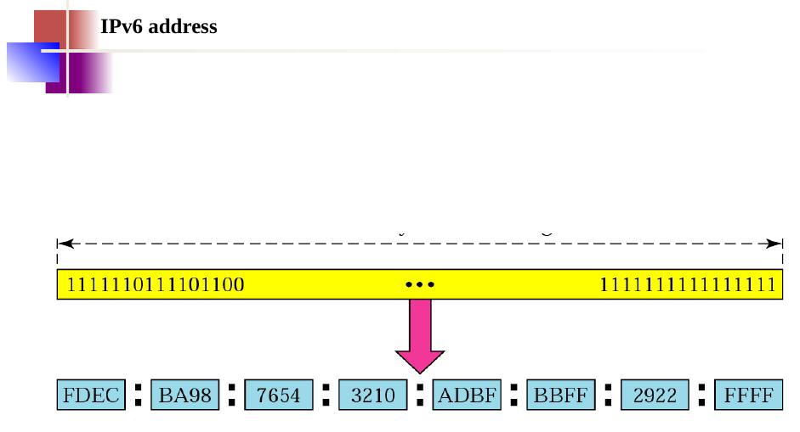
Figure 7.2 — 128-bit IPv6 address shown as binary, then split into 8 groups of 4 hex digits. Example: FDEC:BA98:7654:3210:ADBF:BBFF:2922:FFFF

7.6 IPv6 Datagram Format
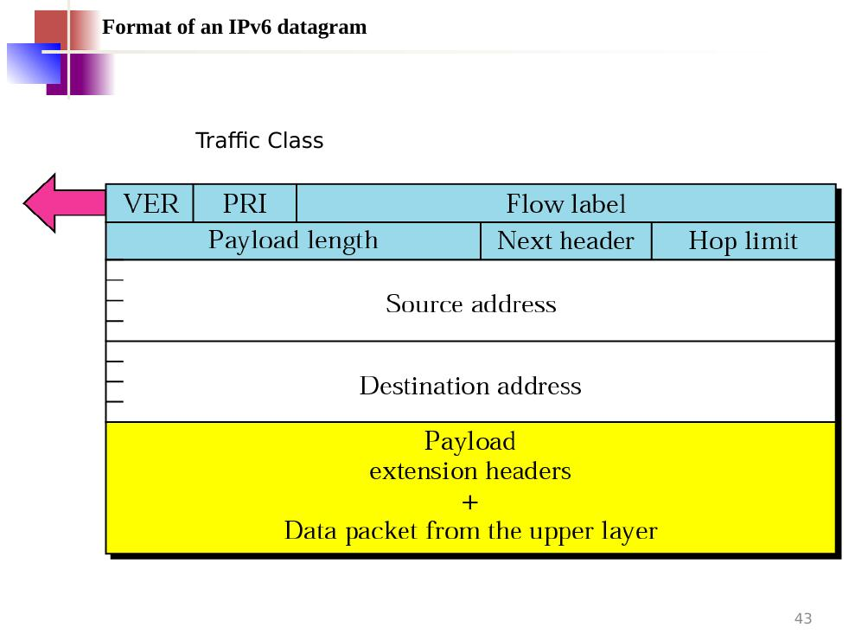
Figure 7.3 — IPv6 header fields. Fixed 40-byte base header (much simpler than IPv4).
- VER (4 bits): IP version = 6.
- PRI / Traffic Class (8 bits): priority of this packet — like the DS field in IPv4.
- Flow Label (20 bits): identifies a sequence of related packets (a 'flow') that need the same treatment, e.g., a video call.
- Payload Length (16 bits): size of the data portion (not including the 40-byte base header).
- Next Header (8 bits): identifies the type of extension header or upper-layer protocol that follows.
- Hop Limit (8 bits): same role as TTL in IPv4 — decremented by each router, packet discarded at zero.
- Source Address (128 bits): sender's IPv6 address.
- Destination Address (128 bits): receiver's IPv6 address.
- Payload: extension headers followed by the data from the upper-layer protocol.

7.7 Fragmentation in IPv6
- In IPv4: both the source computer and any router along the way may fragment a datagram.
- In IPv6: only the source computer is allowed to fragment — routers along the way must NOT.
- The source uses a Path MTU Discovery technique to find the smallest MTU on the entire path before sending.
- If Path MTU Discovery is not used, the source must limit each fragment to 576 bytes or smaller to be safe.

7.8 Three Transition Strategies from IPv4 to IPv6
Because the whole internet cannot switch overnight, three strategies allow old (IPv4) and new (IPv6) systems to coexist.
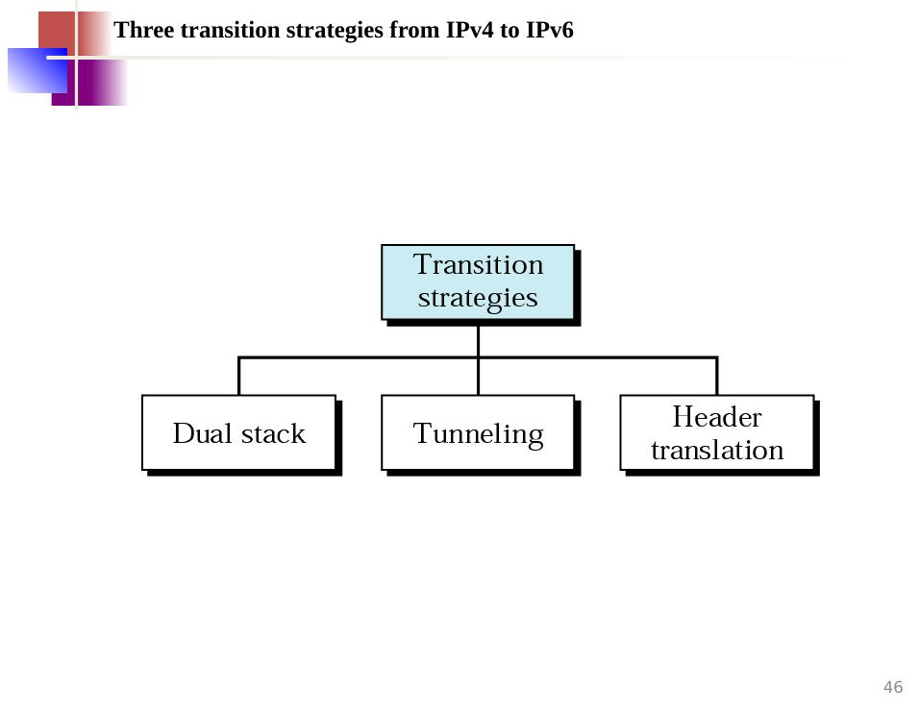
Figure 7.4 — The three strategies: Dual stack, Tunneling, and Header translation.

Dual Stack
A station runs both IPv4 and IPv6 simultaneously until all systems on the internet use IPv6. When sending a packet, the source queries the DNS. If DNS returns an IPv4 address, it sends an IPv4 packet; if IPv6, it sends an IPv6 packet.
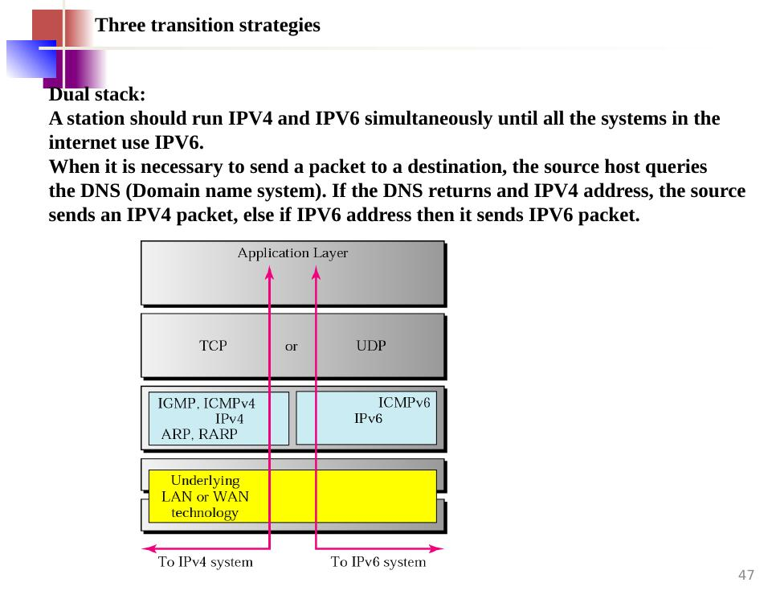
Figure 7.5 — Dual stack: both IPv4 (with IGMP, ICMP, ARP, RARP) and IPv6 (with ICMPv6) run side by side on the same machine, sharing TCP/UDP and the application layer.

Tunneling
When two IPv6 hosts must communicate through an IPv4-only region, the IPv6 packet is wrapped (encapsulated) inside an IPv4 packet. The protocol value in the IPv4 header is set to 41 to indicate it carries IPv6. The IPv4 header is removed when the packet exits the IPv4 region.
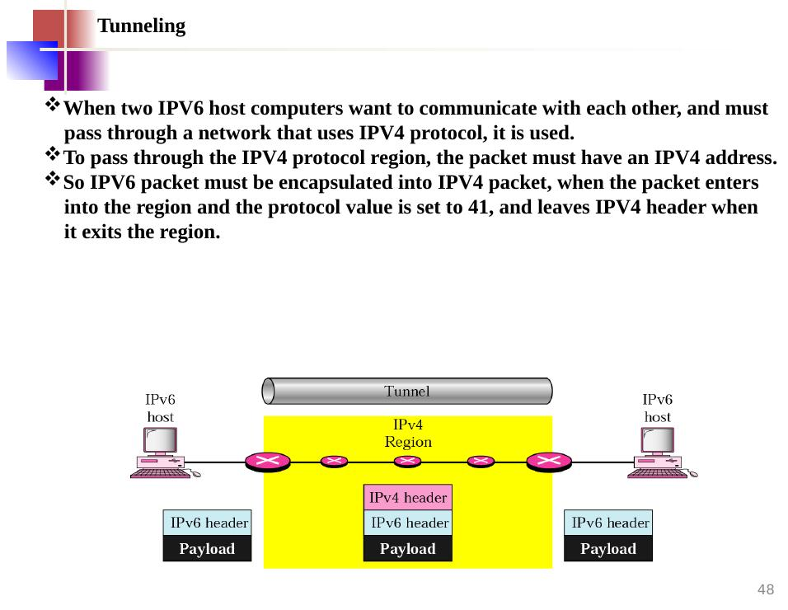
Figure 7.6 — Tunneling: IPv6 packet is wrapped inside an IPv4 packet while crossing the IPv4 region, then unwrapped on the other side.

Header Translation
When the majority of the internet has moved to IPv6 but some systems still use IPv4, and the sender is IPv6 but the receiver is IPv4, tunneling is not enough. The entire header must be fully converted from IPv6 format to IPv4 format by a translator.
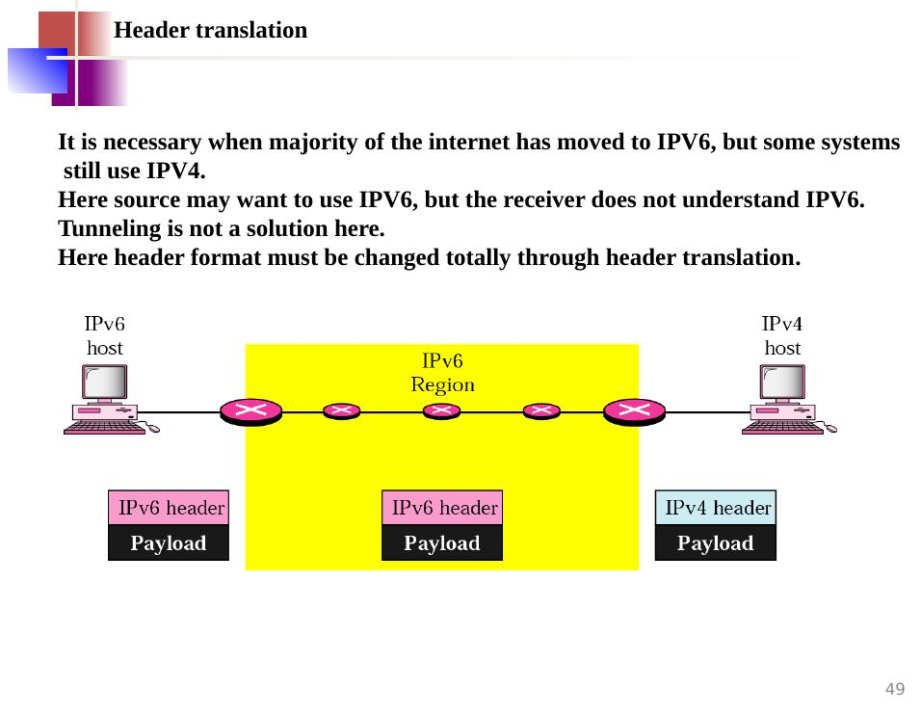
Figure 7.7 — Header translation: an IPv6 host sends into an IPv6 region; the header is translated to IPv4 format so the IPv4 host at the end can receive it.

8. Mobile IP
Normal IP addresses are tied to a specific network. If a laptop moves from one network to another, its old address no longer works for that new location. Mobile IP solves this problem so a device can move freely without losing its connections.

8.1 Two Addresses for a Mobile Device
- Home address: the permanent IP address of the device, just like a permanent home town. It never changes, no matter where the device travels.
- Care-of address: a temporary IP address assigned to the device at the network it is currently visiting, like a temporary holiday address.
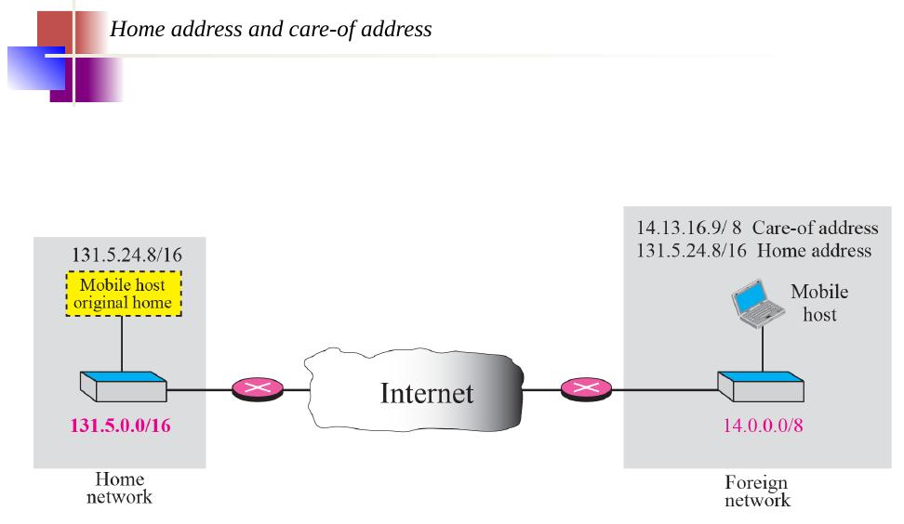
Figure 8.1 — The mobile host has its permanent home address (131.5.24.8/16) plus a temporary care-of address (14.13.16.9/8) at the foreign network.

8.2 Agents — Home Agent and Foreign Agent
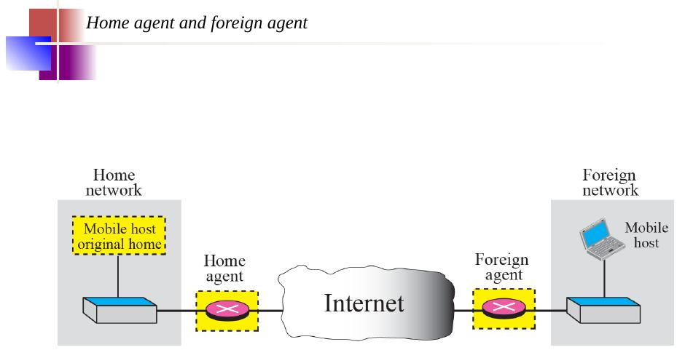
Figure 8.2 — Home agent (at home network) and foreign agent (at visited network) help route packets to the mobile host wherever it is.
- Home Agent: a router at the device's home network that keeps track of where the device is and forwards packets to it.
- Foreign Agent: a router at the visited network that receives forwarded packets and delivers them to the mobile device.
📌 Note: If the mobile device acts as its own foreign agent (co-located mode), the temporary address is called a co-located care-of address.

8.3 The Three Phases of Mobile IP
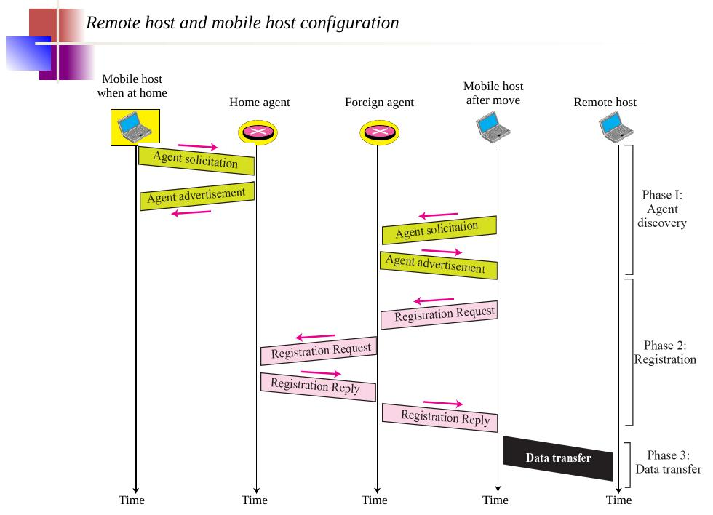
Figure 8.3 — The complete timeline: Phase 1 (Agent Discovery) → Phase 2 (Registration) → Phase 3 (Data Transfer).

Phase 1 — Agent Discovery
The mobile device learns whether it is at home or away, and finds the nearby foreign agent. Two ICMP-based messages are used:
- Agent Advertisement: agents periodically broadcast their presence and list of available care-of addresses.
- Agent Solicitation: if the mobile device does not want to wait, it sends a solicitation message asking "Is any agent here?"
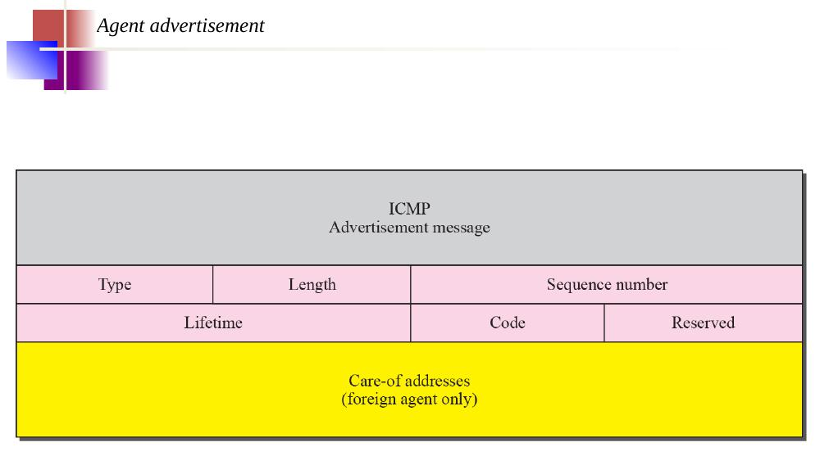
Figure 8.4 — Format of the Agent Advertisement message (an extension added to the standard ICMP router advertisement).
📌 Note: Mobile IP does not use a new packet type for agent advertisement — it uses the ICMP router advertisement packet and appends an agent advertisement message.
📌 Note: Mobile IP does not use a new packet type for agent solicitation — it uses the ICMP router solicitation packet.
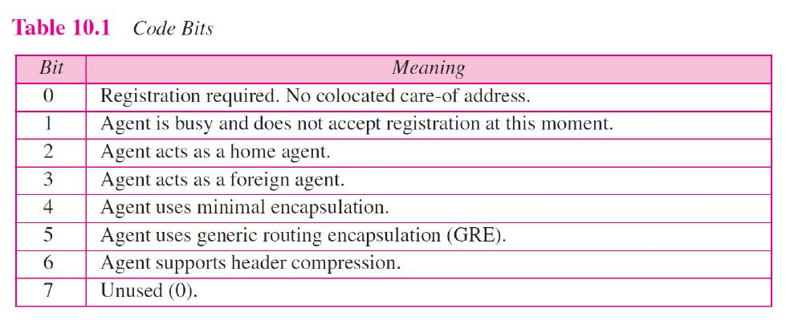
Table 8.1 — Code bits in the Agent Advertisement message and their meanings.

Phase 2 — Registration
After finding a foreign agent, the mobile device registers its location using two messages: a Registration Request and a Registration Reply. These travel using UDP on port 434.
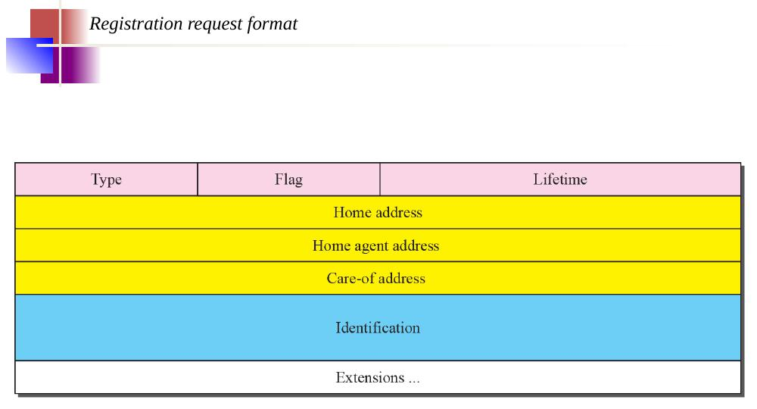
Figure 8.5 — Registration Request format: Type, Flag, Lifetime, Home address, Home agent address, Care-of address, Identification, Extensions.
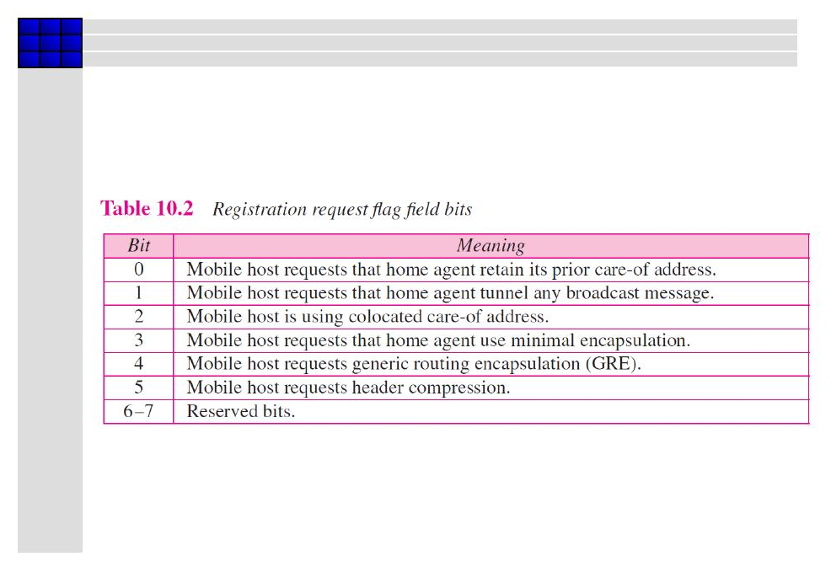
Table 8.2 — Registration Request Flag field bits and their meanings.
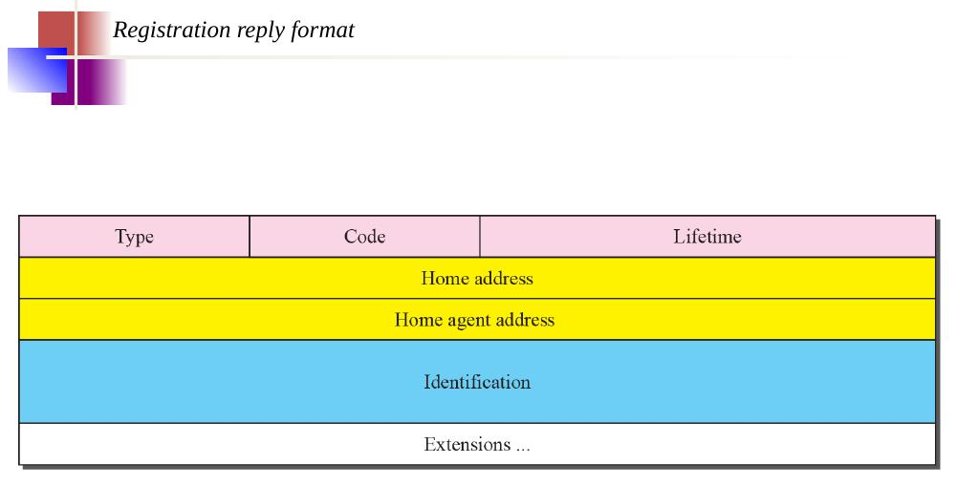
Figure 8.6 — Registration Reply format: Type, Code, Lifetime, Home address, Home agent address, Identification, Extensions.

Phase 3 — Data Transfer
Once registered, data flows between the mobile host and the rest of the internet:
- Remote host sends a packet to the mobile host's home address.
- The home agent intercepts it and tunnels (encapsulates) the packet, forwarding it to the care-of address.
- The foreign agent decapsulates the packet and delivers it to the mobile host.
- Packets from the mobile host back to the remote host travel directly, without going through the home agent.
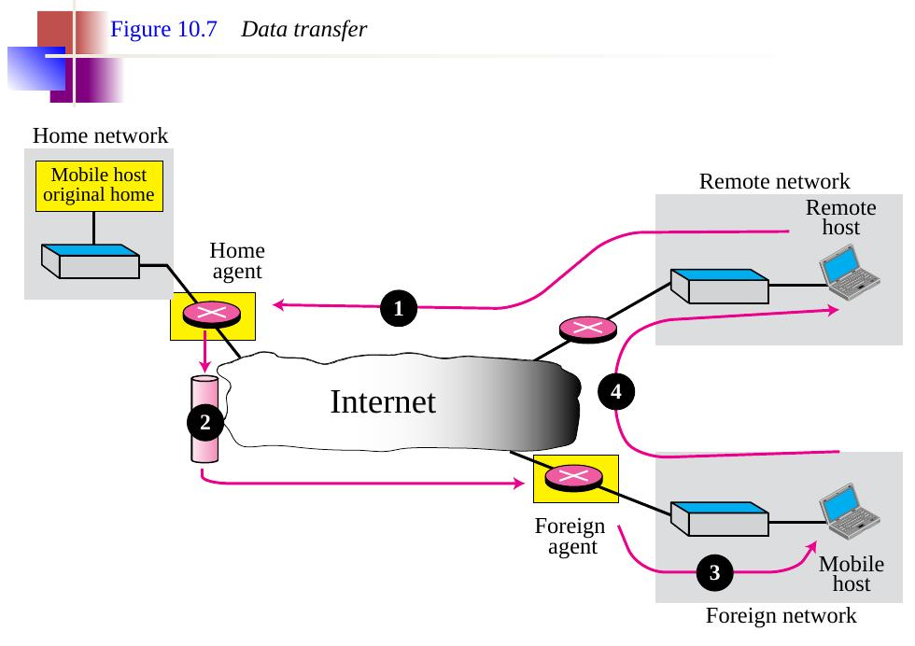
Figure 8.7 — Data transfer flow: (1) Remote host → Home agent; (2) Home agent tunnels to Foreign agent; (3) Foreign agent → Mobile host; (4) Mobile host → Remote host directly.
📌 Note: The movement of the mobile host is transparent to the rest of the internet — the remote host never needs to know the mobile host has moved.

8.4 Inefficiency in Mobile IP
Because of the way home and foreign agents are used, packets do not always travel by the shortest path. This creates two types of routing inefficiency:

Double Crossing
This is the more wasteful case. When a remote host and the mobile host happen to be on the same foreign network, packets still travel all the way back to the home network and then forward again — crossing the internet twice unnecessarily.
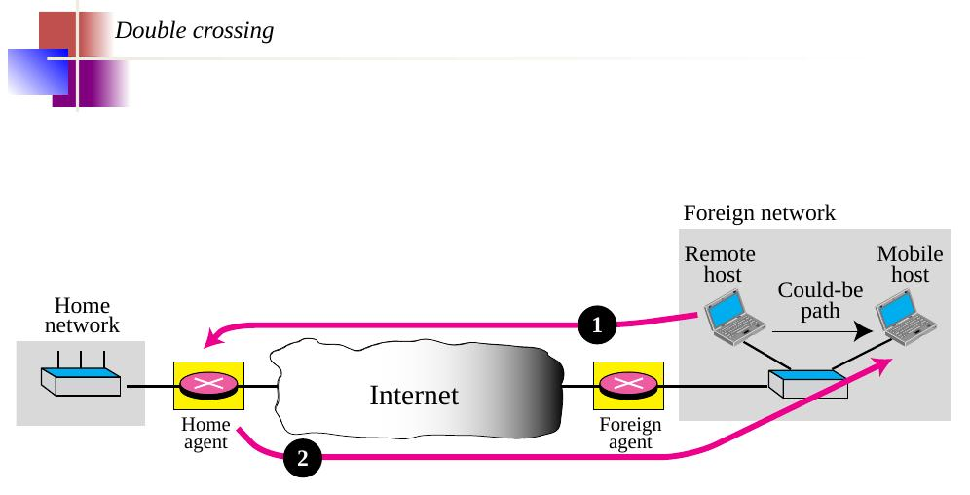
Figure 8.8 — Double crossing: packets go (1) from remote host to home agent and (2) back out from home agent through the internet to the foreign agent, instead of going directly.

Triangle Routing (Dog-Leg Routing)
This is the milder, more common case. Even when the remote host and mobile host are reasonably close to each other, the packet still takes a longer triangle-shaped path via the home network instead of going directly.
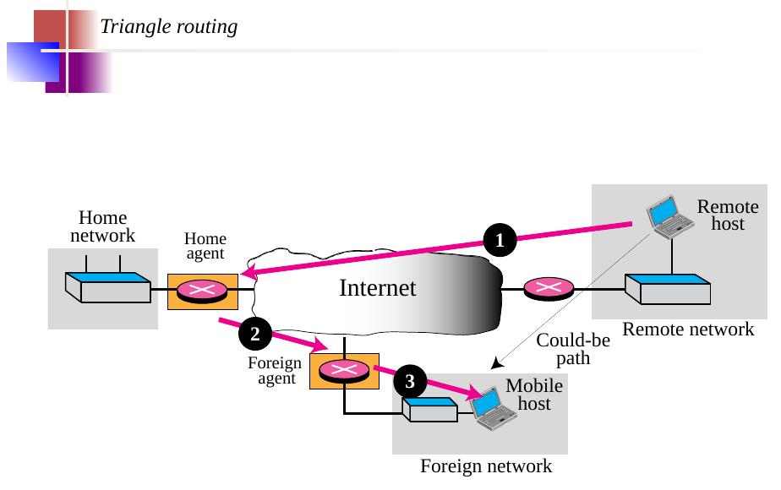
Figure 8.9 — Triangle routing: packet travels (1) remote host → home agent, (2) home agent → foreign agent, (3) foreign agent → mobile host, instead of (the shorter) remote host → foreign agent → mobile host.

